Elegant Women’s Necklaces Australia: Discover InSync Design’s Unique Collection

When it comes to making a statement with your jewelry, nothing compares to a beautifully crafted necklace. Whether you're dressing up for a special occasion or adding a touch of elegance to your everyday look, the right necklace can transform your outfit. If you’re searching for unique women’s necklaces in Australia, look no further than InSync Design—a brand that combines innovation, craftsmanship, and artistry to create standout pieces.

Why Choose InSync Design for Women’s Necklaces?
InSync Design is more than just a jewelry brand; it celebrates contemporary art and timeless elegance. Every piece is meticulously handcrafted, ensuring you receive a unique accessory that reflects your personality and style. Here’s what sets InSync Design apart:

1. Unique, Handmade Craftsmanship
Unlike mass-produced jewelry, InSync Design’s necklaces are handcrafted by skilled artisans. Each piece embodies the perfect balance of creativity and precision, making it a wearable work of art.

2. Premium-Quality Materials
Quality matters when it comes to jewelry. InSync Design uses high-quality materials, including stainless steel, gold-plated finishes, and innovative textures that ensure durability and elegance.

3. Bold and Distinctive Designs
Forget ordinary necklaces—InSync Design offers bold, contemporary designs that stand out. Whether you love minimalist aesthetics or intricate statement pieces, there’s something in the collection to suit your taste.

4. Designed for Every Occasion
From sophisticated pieces for formal events to everyday wear that adds a subtle touch of elegance, InSync Design’s necklaces cater to all styles and occasions.
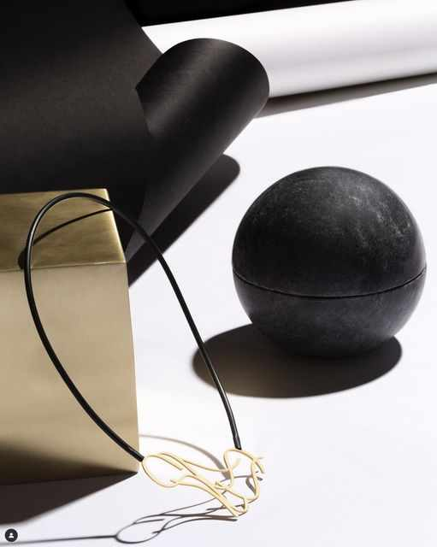

Explore the Stunning Collection
At InSync Design, you’ll find an array of necklaces that redefine modern elegance. Some of the standout collections include:

Statement Necklaces: Make a bold impression with artistic, eye-catching designs.

Minimalist Pieces: Perfect for those who love understated beauty.

Layered Necklaces: Create a chic, contemporary look by layering delicate chains and pendants.

Geometric Styles: A modern twist on classic designs, incorporating unique shapes and patterns.

How to Style Your InSync Design Necklace
Wondering how to incorporate these stunning pieces into your wardrobe? Here are some styling tips:

For Workwear: Pair a sleek, minimalist necklace with a tailored blazer or blouse for a refined, professional look.

Casual Chic: Layer delicate necklaces over a simple tee or dress for an effortlessly stylish vibe.

Evening Glam: Opt for a statement piece that complements your dress and enhances your neckline.

Shop Women’s Necklaces in Australia Today
Ready to elevate your jewelry collection? Explore InSync Design’s exquisite range of women’s necklaces Australia and find the perfect piece that speaks to your style. Whether you’re treating yourself or looking for a thoughtful gift, these handcrafted designs will impress.

Styling Your InSync Design Necklace
Casual Chic: Pair a minimalist necklace with a crisp white shirt and jeans for an effortlessly stylish look.
Workwear Ready: Elevate your office attire with a structured pendant necklace over a tailored blazer.
Evening Glam: Make a statement with a bold sculptural piece that enhances your little black dress.

Layered Look: Combine different lengths and textures for a modern, layered jewelry style.

Where to Buy Women's Necklaces in Australia
You can explore and shop InSync Design’s unique necklace collection online. With worldwide shipping and a commitment to quality, finding the perfect necklace has never been easier.

Elevate Your Jewelry Collection with InSync Design
If you're looking for women's necklaces in Australia that combine artistic expression with impeccable craftsmanship, InSync Design is your go-to brand. Embrace individuality, support local artisans, and make a lasting style statement today.

Final Thoughts
A necklace is more than just an accessory—it reflects your personality and style. InSync Design offers a collection of beautiful, handcrafted women’s necklaces in Australia. These necklaces cater to fashion-forward individuals who appreciate artistry and quality. Elevate your look with a unique piece from InSync Design today.

