Shake Up Your Fitness Routine with Kings Gym’s Protein Shaker Bottle
When it comes to achieving your fitness goals, every detail counts. From your workout regime to your diet plan, and yes, even your gear. The Kings Gym Protein Shaker Bottle is not just another gym accessory; it’s your perfect companion for mixing and enjoying protein shakes and supplements with ease and style.

Why the Right Shaker Bottle Matters
A protein shaker bottle might seem like a minor detail, but it’s a game-changer for anyone serious about fitness. Here’s why:
- Convenience: Easily mix protein powders, pre-workouts, or hydration drinks without lumps.
- Portability: Designed to go wherever you go, from the gym to the office.
- Durability: A high-quality shaker lasts longer and performs better.
The Kings Gym Protein Shaker Bottle ticks all these boxes, making it a must-have for your fitness routine.

Why a High-Quality Protein Shaker is Essential
Imagine this: You’ve just wrapped up a killer workout. Your muscles are screaming for recovery, and you’re ready to refuel with a protein shake. But instead of a smooth, creamy drink, you’re stuck with lumps of powder. Frustrating, right? That’s where a premium shaker bottle like Kings Gym’s comes in.
Our protein shaker bottle is designed to:
- Eliminate Clumps: No more chewing your shakes. The advanced mixing technology ensures a silky-smooth blend every time.
- Enhance Convenience: Lightweight and portable, it fits seamlessly into your gym bag.
- Support Your Goals: Proper nutrition is key, and this bottle ensures you’re always ready to refuel.
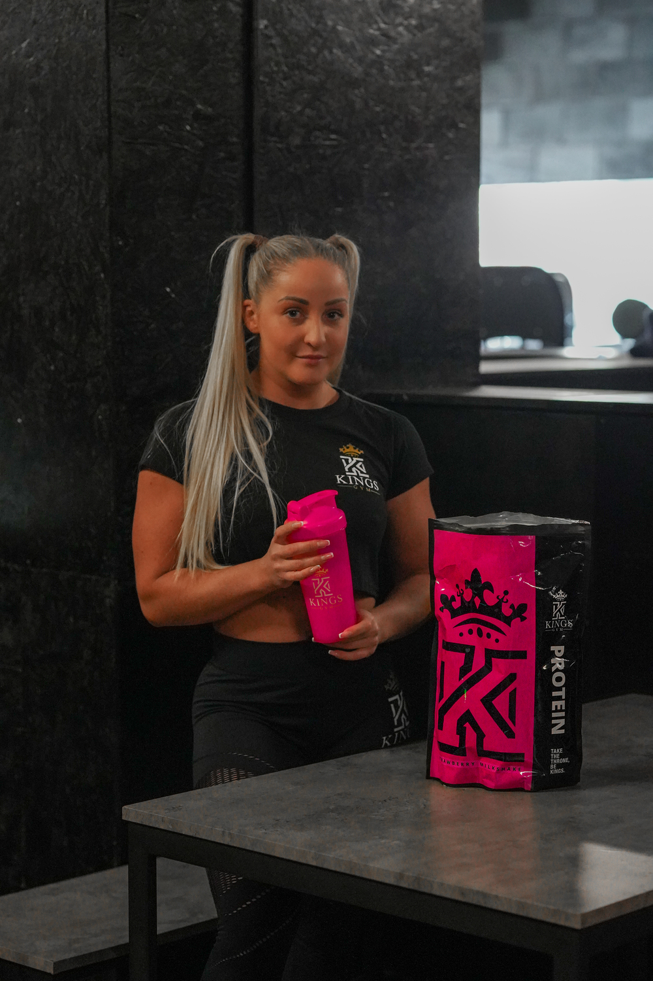

Features of the Kings Gym Protein Shaker Bottle

1. Leak-Proof Design
No one likes a gym bag disaster. The Kings Gym shaker features a secure, leak-proof lid that ensures your drinks stay where they belong—inside the bottle.

2. BPA-Free Material
Your health is our priority. Made from BPA-free materials, this shaker is safe for daily use and ensures your drink remains pure and untainted.

3. Built-In Mixing Ball
Forget the days of clumpy shakes! The stainless steel mixing ball blends your protein powder smoothly for a perfectly textured drink every time.

4. Sleek and Functional Design
Available in a stylish black and gold finish, the shaker bottle reflects the premium Kings Gym brand. It fits comfortably in your hand, cup holder, or gym bag.

5. Easy to Clean
Dishwasher-safe and easy to rinse, the shaker bottle is as low-maintenance as it is high-performing.

How to Use the Kings Gym Protein Shaker Bottle
Using the shaker is simple:
- Add your desired amount of liquid—water, milk, or a plant-based alternative.
- Scoop in your protein powder or supplement.
- Drop in the mixing ball, close the lid securely, and shake it up!
- Enjoy your perfectly blended drink.

Benefits Beyond the Gym
The Kings Gym Protein Shaker Bottle isn’t just for post-workout protein shakes. Use it to:
- Mix pancake batter for a quick breakfast.
- Blend smoothies on the go.
- Stay hydrated with electrolyte mixes.

Why Choose Kings Gym?
Kings Gym is a name synonymous with quality, performance, and style. Whether you’re a seasoned fitness enthusiast or just starting your journey, our products are designed to support and inspire you every step of the way.
With the Kings Gym Protein Shaker Bottle, you’re not just investing in a piece of gym equipment. You’re embracing a lifestyle that prioritizes health, convenience, and excellence.

Wrap-Up: Elevate Your Workout Game
Don’t let clumpy shakes or messy spills slow you down. The Kings Gym Protein Shaker Bottle is your reliable partner for seamless supplementation. Order yours today and take the first step toward upgrading your fitness routine.

